Year 11 Trip to Reading University
Our Year 11s have been visiting universities over the past few weeks with the aim to raise aspirations and inform students about further and higher education opportunities.
Some of our students visited Reading University. Reading is a leading UK university and offers a wide range of degree programmes encompassing the pure and applied sciences, social sciences, languages, arts, humanities, business and many more. It is ranked 30th in the UK and 19th in the world
Students were introduced to University life and toured the campus. They took part in two taster sessions: The Science of the Brain and the Chemistry of Chocolate and had a Q&A session with student ambassadors

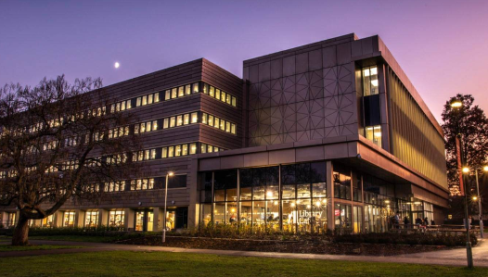
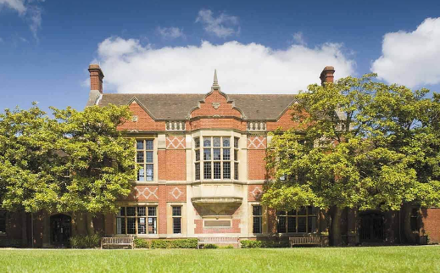
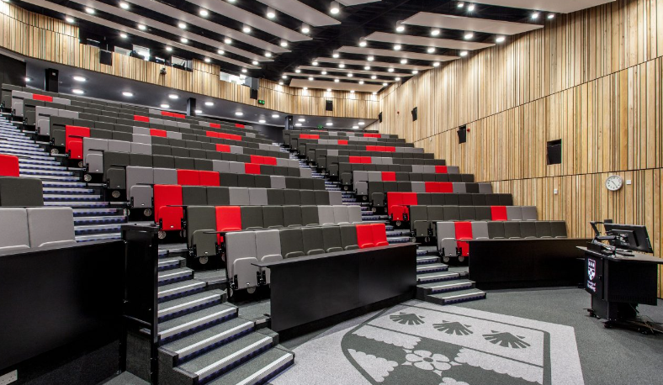

“There were so many facilities and clubs on offer to students and I especially like the science facilities. I had never thought about university before and now I know there is a possibility and would like to study sociology criminology and forensics. I enjoyed the Chemistry of Chocolate session and the museum tour” Grace

“The University of Reading had a large campus and we had a tour from student ambassadors, they answered all of our questions and told us about University life. We went into a museum where we saw skeletons of animals which was very interesting to see and learnt about things such as evolution. Also, we saw various buildings such as the business school, showing just how many courses they have to offer. Later on in the day we took part in a session learning about the science of the brain which I found extremely intriguing, during the session we watched videos and took part in activities to understand how long the brain takes to process different information. Towards the end of the trip, we learnt about the chemistry behind cacao and did a blind chocolate tasting which again was all to do with the brain. There was also a student life talk and we were able to ask anonymous questions on post-it notes. This was a great idea because it meant that everybody could ask questions such as 'what societies are you in?'. I found the day really interesting and eye opening into the university life and gave a good idea of what it is like to go to university. Anna

I particularly enjoyed the Stroop test and the optical illusions along with the attention test as I loved learning about how the brain worked. Jon

