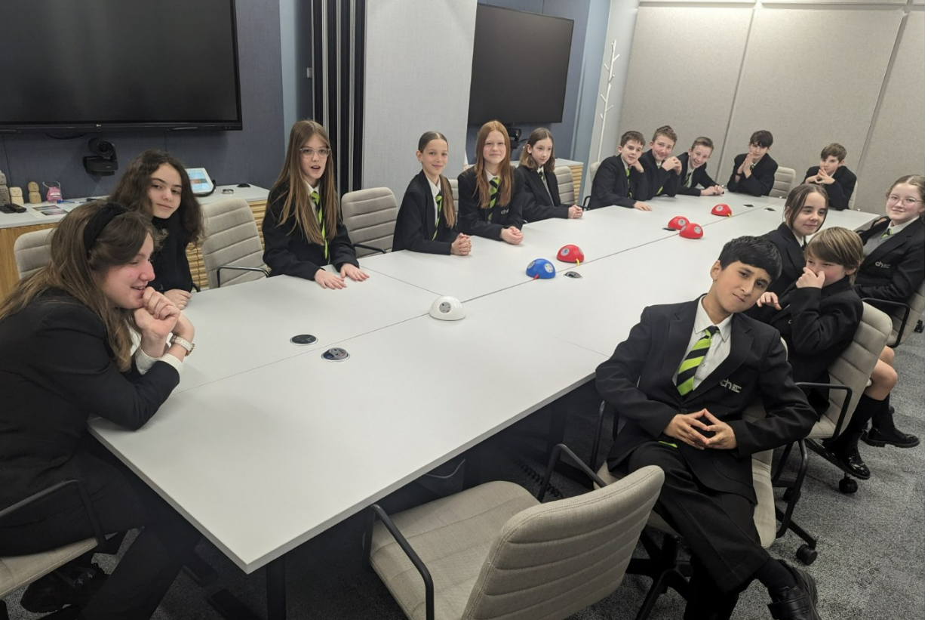
Year 11 Work Experience at PwC Offices March 2024

Last Thursday we took 30 Year 7 students to PwC offices in Watford. Students experienced a careers journey talk, planned and presented within groups about sustainability and had an interesting tour of the offices. The students then had lunch and ended the day back in groups considering how to encourage women into technology roles. The staff at PwC were very impressed with our students and identified some of our leaders of the future!

