Sixth Form Visit to the Palace of Westminster
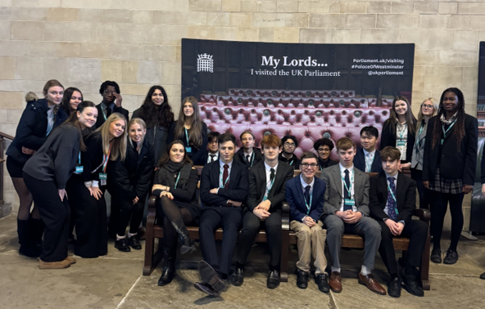
On Wednesday 3rd December, our Sixth Form students had the exciting opportunity to visit the Palace of Westminster, gaining a first-hand look at the heart of UK democracy. The visit began with a guided tour of the historic building, including the iconic House of Lords. Students were in the right place at the right time to witness the Speaker’s procession as it made its way into the House of Commons for Prime Minister’s Questions, a highlight that brought Parliament’s traditions vividly to life.
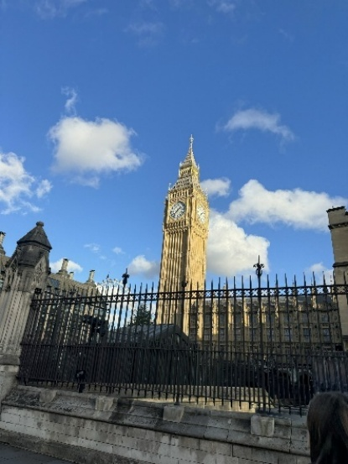
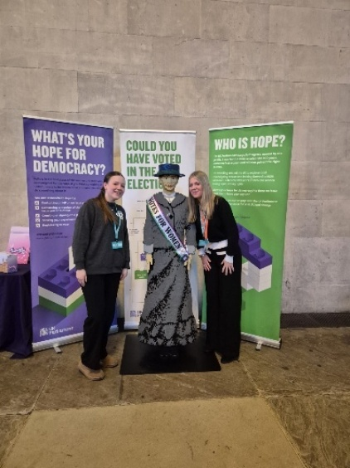
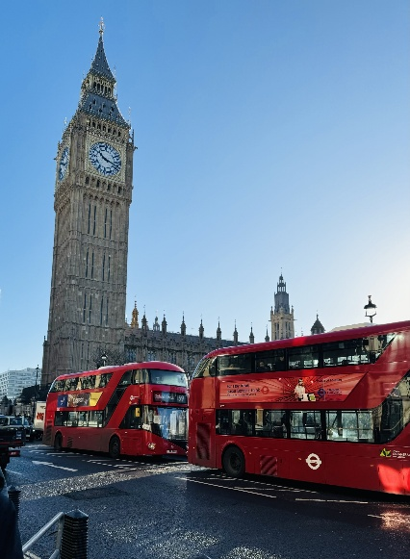

As they explored the ornate halls and chambers, students were struck by the grandeur of the Palace and fascinated by the insight they gained into Britain’s political system. They learned about how MPs are elected and were surprised to discover that the youngest current MP is just 22 years old.
A key part of the visit was a meeting with MP Christian Wakeford, Government Whip and Lord Commissioner of HM Treasury. Mr Wakeford shared his personal journey into politics, explaining how his career developed and why political engagement matters to everyone, especially at a local level. He described the unpredictable nature of parliamentary life, noting that some days can end with voting sessions stretching until 2am.
To round off the day, students took part in an engaging workshop where they formed their own political parties. Working in groups, they created manifestos covering social, educational and environmental policies. After presenting their ideas, a snap election was held. The winning party impressed their peers with a standout pledge: offering free university tuition for first-generation university students
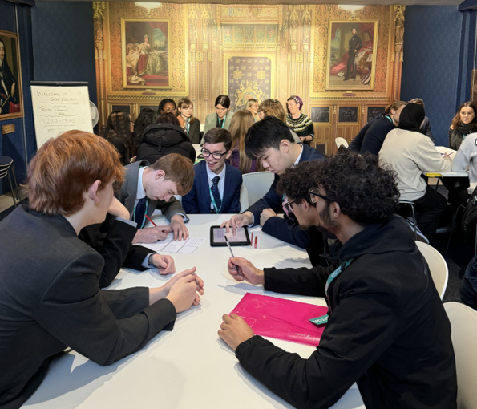
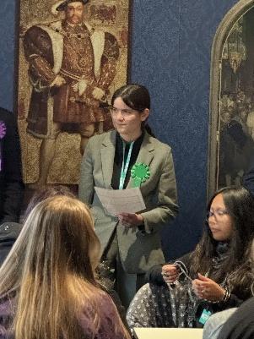
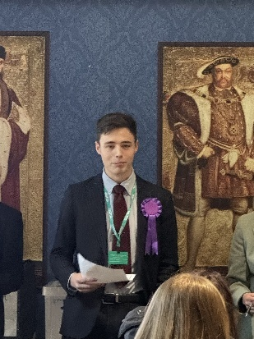
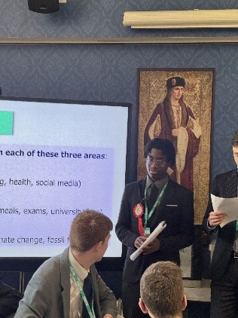
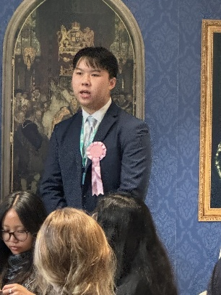

The visit offered an inspiring glimpse into the workings of government and encouraged many students to think more deeply about the role politics plays in shaping society. It was a memorable day that brought classroom learning to life in one of the most significant buildings in the country
“I learned so much about politics, it was fascinating” Flo
“The tour of Westminster was really amazing. I learned a lot” Hannah
“I enjoyed understanding more about the political parties in our county. It was fascinating to find out about all the different event that have taken place in Westminster” Emma
“I found out a lot of new information about Parliament that I did not know, and the workshop was really interesting and fun” Freddie
“They way Parliament works is much more complex than I thought which is interesting and makes me want to learn more” Oliver

