Exploring Legal Careers- Inspirational and Insightful Talk from a Criminal Barrister
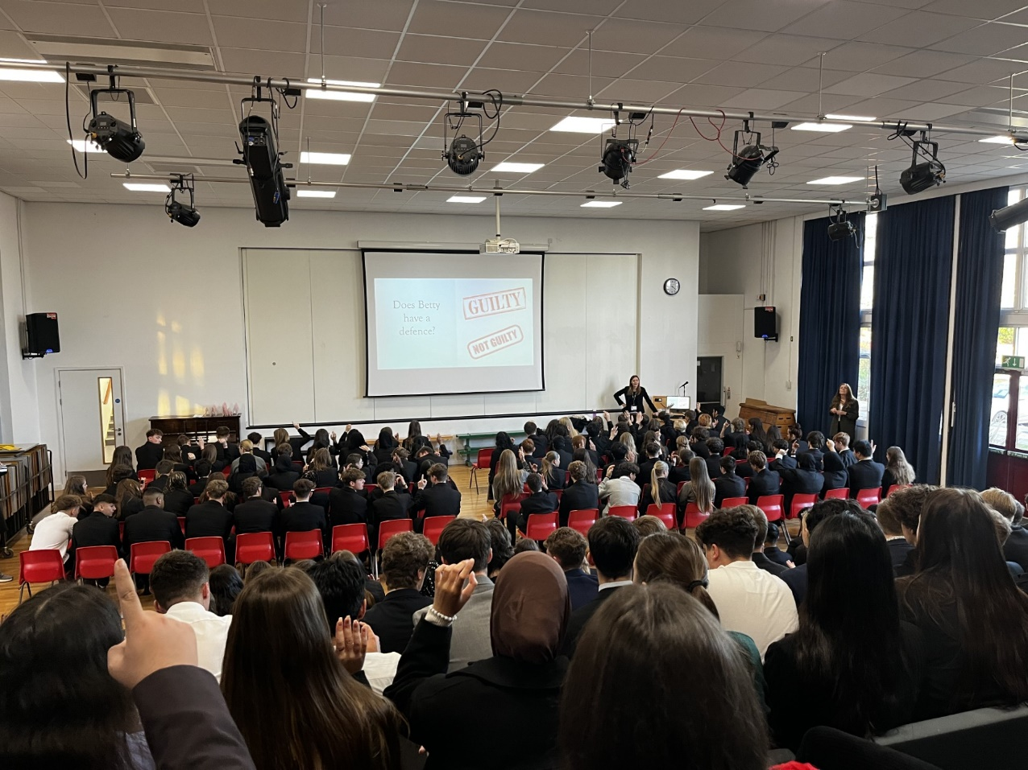

On Friday, students in Years 9, 10, 11, and Sixth Form were treated to an engaging talk from Criminal Barrister Natalie Turner. Natalie shared her extensive knowledge of the legal profession and offered valuable advice on the various pathways into law. She even brought along her barrister’s gown, wing-collar, and, of course, her iconic wig!
To bring the role of a barrister to life, Natalie took students through a fascinating case study of Betty, a client accused of attempted burglary. Students had the opportunity to examine the evidence and engage in an interactive debate about the case, which was both thought-provoking and educational.
Natalie spoke candidly about the highs and lows of her career, revealing that it took her 12 years to qualify as a barrister. Her honesty and insights into the profession were greatly appreciated by all who attended.
We would like to extend a huge thank you to Natalie for delivering such an excellent and inspiring session. If any students would like further information about pursuing a career in law or the application process, please feel free to contact the Careers Department directly

