Pinewood Futures Festival – Media Careers

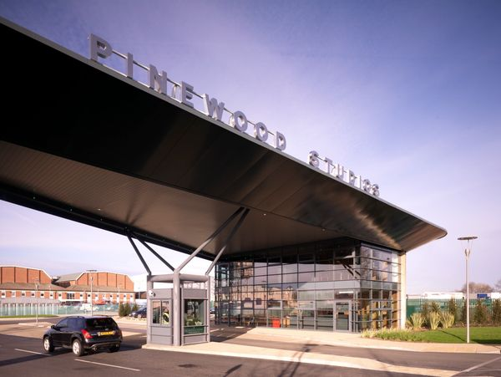

Last week our Sixth Form Media students attended Pinewood’s Future Festival – the UK’s biggest screen industry careers event.
Our students had the chance to meet employers and industry professionals and take part in workshops across the various departments of film and television production; art, costume, props, lighting, construction, camera, script writing, special effects and so much more.
They attended a fascinating talk with Chris Corbould, Academy Award winning Special Effects Supervisor and Director, who has worked on 15 James Bond films, XMen & Star Wars. Students also heard form Sonja Klaus, a leading Film and Television designer who has worked on Oscar winning epic Gladiator, American Gangster, Prometheus, Robin Hood and Tomb Raider.
There were literally hundreds of careers opportunities which our students were able to explore in an interactive and immersive experience. A fantastic opportunity to inspire, engage and encourage our Media students to consider a career in the screen industry.

The visit to Pinewood Studios proved to be a great experience as it provided valuable insights into the media industry. Observing and interacting with professionals facilitated an understanding of potential career pathways, we even got the chance to appear in movies as extras which made the experience even better. Overall, this trip was brilliant as it provided crucial information about the media industry and an enjoyable experience
Jordan Varga

The trip to Pinewood was a great insight into the media industry for everyone. As we got to see the media visually, it was great to understand different roles that are involved in various careers- to consider for my future. It was a pleasure to interact with many workers from the industry, and got to receive invites to begin work in media. Generally, it made me realise how many careers there are in the media industry, the possibilities are endless.

Anissa Trevathan

