TALKING CAREERS IN THE ARMY

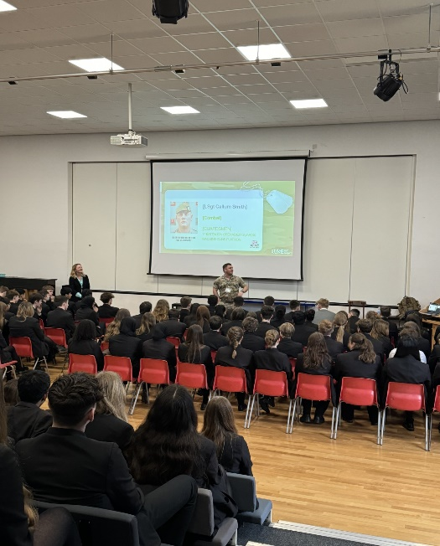

As part of our Careers Programme we invite speakers into school to inform students of the various career opportunities available with the aim to ignite that spark of career interest that they never knew existed.
This week we were fortunate to have The Army come into CHA. Students heard from Sgt Callum Smith, a highly dedicated team member with 14 years’ experience in the Army including patrols in Iraq and Afghanistan. He explained how there are many different career pathways at age 16, 18 or after University – The Army will even fund your University Degree!
There are over 200 different careers available from logistics, planning, electricians, bricklayers, combat soldiers, nursing, surgeons, vets, finance & HR, intelligence data analysts and even musicians. Those entering The Army will gain qualifications whilst being paid and there is an opportunity to train in different departments which is useful if you are not exactly sure of your specialism.
It was a fascinating talk about life in the Army, the starting salaries, apprenticeships, the challenges and how camaraderie binds everyone together. Joining the Army will teach you leadership, resilience, coping strategies, decision making, teamwork and courage. We also heard how the possibilities for adventure are huge. You could find yourself doing something you never thought possible, from wreck diving off the coast of New Zealand to white- water kayaking in the Sjoa River in Norway.
A huge thank you to The Army for such an interesting careers talk.

