Y10 Visit to Bucks Skills Show 2024
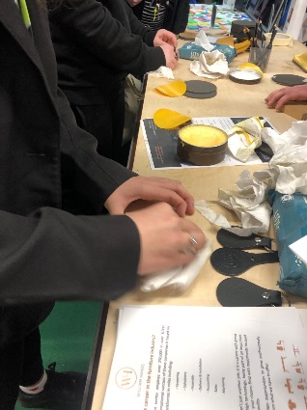
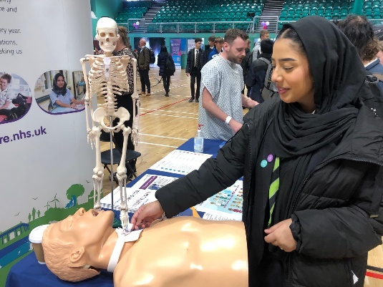
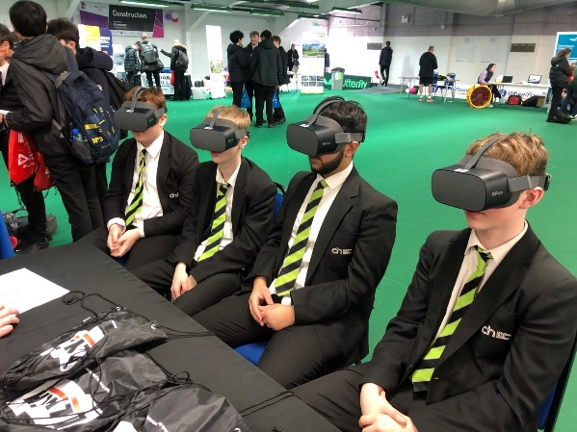

Last week Year 10 visited the Bucks Skills Show. With over 100 businesses and organisations attending, it was the perfect opportunity to meet a wide range of employers from local, national and international industries keen to spot the talent of the future. Our students discovered what it was like to work in key industries, what skills and qualifications they need to get their first job and what steps they should take between now and at the point of application.
There was also an opportunity to meet with Further Education providers to help students plan their next steps.
Students took part in multiple interactive activities and networked with representatives from:
- Creative Film and TV
- High Performance Engineering and Manufacturing
- Medical, healthcare and social care
- Hospitality, Leisure and Tourism
- Digital Technology
- Charity and Public Services
- Construction
- Civil Engineering
- Business, Finance and Professional services
- Next Steps – Further Education, Higher Education, Training & Development

“The Bucks skills show 2024 opened our eyes to a lot of opportunities and careers in the future. I loved that there was a wide variation, including, Space, Drama and Media, NHS, Construction, Technology and so much more. The people from the businesses, universities, college and charities were very welcoming and were happy to answer any questions. As well as that they also had many interactive activities we could do, for example doing CPR, listening to a child’s chest and so much more. I’m so glad I got to go to this event as it has helped me discover more career options for the future” Erin & Layla 10CLR

“The Bucks Skills Show was a fantastic opportunity to discover many careers in fields which many students may not have considered. The staff at the stands were very friendly and gave a brilliant explanation about their industry. The Bucks Skills Show helped inspire students and help them explore many different career paths. Many stands had cool gadgets such as the portable ultrasound or the walking dog-like robot. These tools gave us a good feel about what a career in that industry would be like. Overall the Bucks Skills Show was an opportunity to discover the many careers life has to offer”. Finn 10 CLR

