Year 10 Careers Inspiration at the Bucks Skills Show
Last Wednesday, our Year 10 students attended the Bucks Skills Show, Buckinghamshire’s largest and most dynamic careers event. The visit formed part of our ongoing commitment to broadening students’ horizons by showcasing future career pathways, training opportunities, apprenticeships, and routes into employment and higher education.
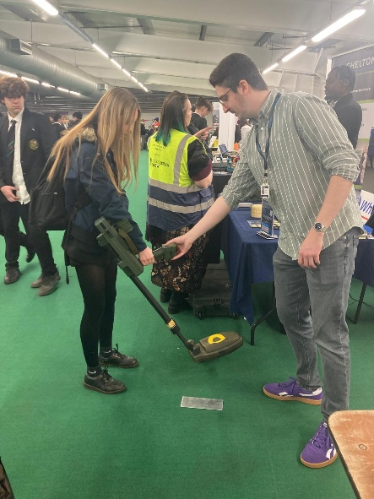
The Skills Show brought together over 120 employers and organisations representing a wide range of sectors, including construction and engineering, creative film and TV, digital technology, healthcare, business and finance, hospitality, and the public sector. This provided students with a valuable opportunity to network directly with employers and industry professionals who are actively recruiting the workforce of the future.
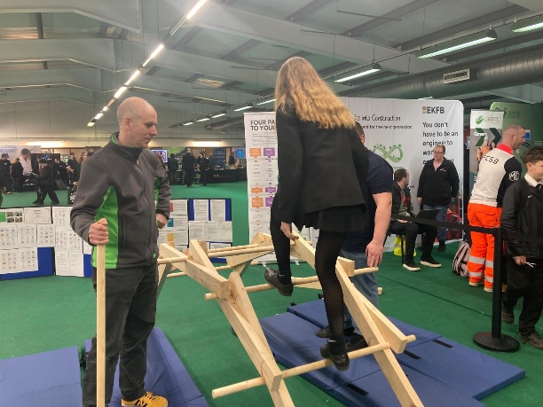
In addition, students met with universities, colleges, apprenticeship providers and training organisations, all ready to offer guidance on next steps in education and career planning.
Mrs Hemsworth, Careers Lead and Head of Sixth Form, said:
“It was brilliant to see our Year 10 students so engaged, curious and forward-thinking at the Bucks Skills Show. Events like this highlight the wide range of pathways available and help students make informed choices about their next steps.”
Students were equally positive about their experience:
“It was so interesting looking at different career paths. It gave me ideas on what to do” Sara
“I found many things to help with my career plans” Alfie
“The business section helped me with my dream career and I liked the interactivity at the event” Isabella
The photography, construction and engineering stands helped me decide what to do after school” Saaliha
We are proud of the enthusiasm and maturity our Year 10 students demonstrated throughout the event and look forward to supporting them as they begin to shape their future pathways

