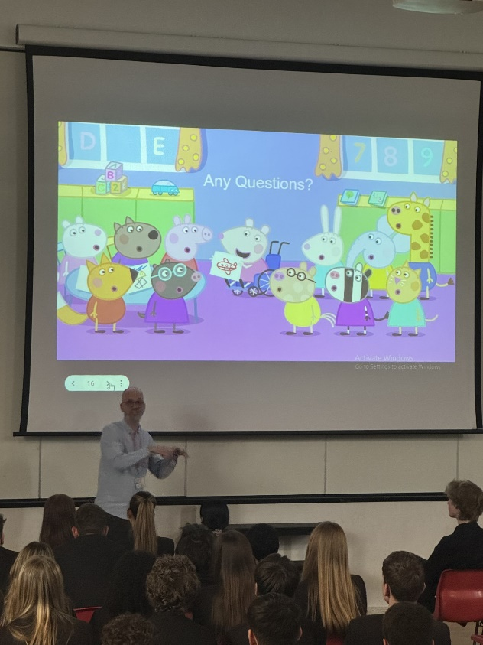
Career Talks – James Butler, Layout Artist on Peppa Pig
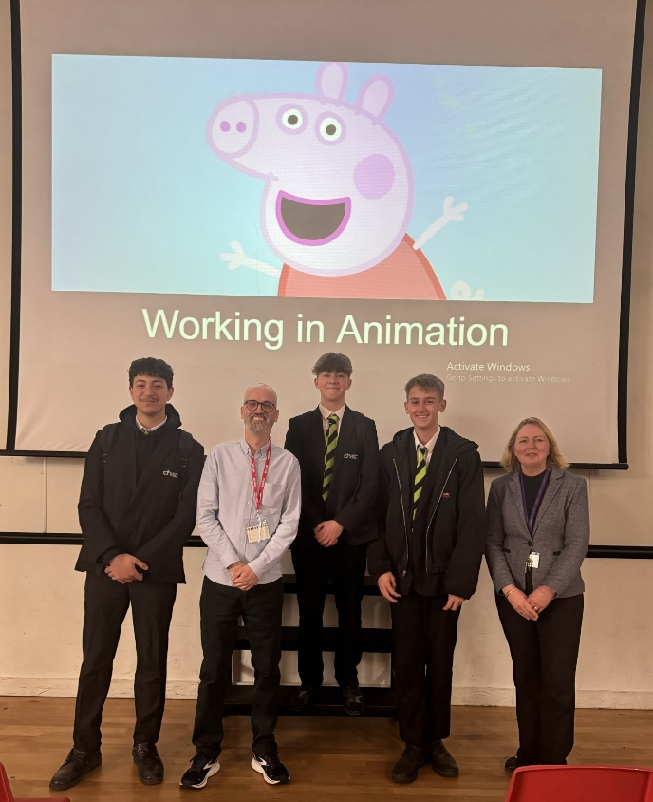
On Tuesday we were very fortunate to welcome James Butler who has over 20 years’ experience in the Animation and Creative industry.

Since 2006, James has worked on BAFTA and Emmy winning shows including Peppa Pig and Ben & Holly’s Little Kingdom. He also has experience on working on feature films, commercials and series animation

We learned how there are 2.2 million jobs in the creative industry and the whole industry generates £108 billion per year to the British economy.

James talked about his journey into animation from having to drop Art in Sixth form as it clashed with Maths, to going on to do a degree in Electronic Imaging and Media Communications.

James explained that it takes one whole day to produce 4 seconds of Peppa Pig and three years to make a new series. Students were taken through the fascinating process from script writing, storyboard, voice record, layout, animation and sounds FX, Edit and Music

Within the Animation team there are over 40 roles including designers, art directors, producers, accountants, editors and writers, many being neurodivergent.

Students then asked James many interesting questions about his career. We would like to thank Speakers for Schools for matching us up with James. Speakers for Schools, a charity, is helping us make sure our students can access inspirational opportunities and experiences to fuel their ambition and raise aspirations.
“James was very informative about the how process of animation and the different jobs within the industry. I was impressed by everything that he had worked on previously and he explained very well how he started out, the barriers and positives of doing being involved in animation”. Summer (11SAM)

“The talk demonstrated the importance of animation and how intricate the entire process is. I was unaware of the wide variety of roles the animation industry has to offer including riggers, writers and directors” Liam (Yr 12)

