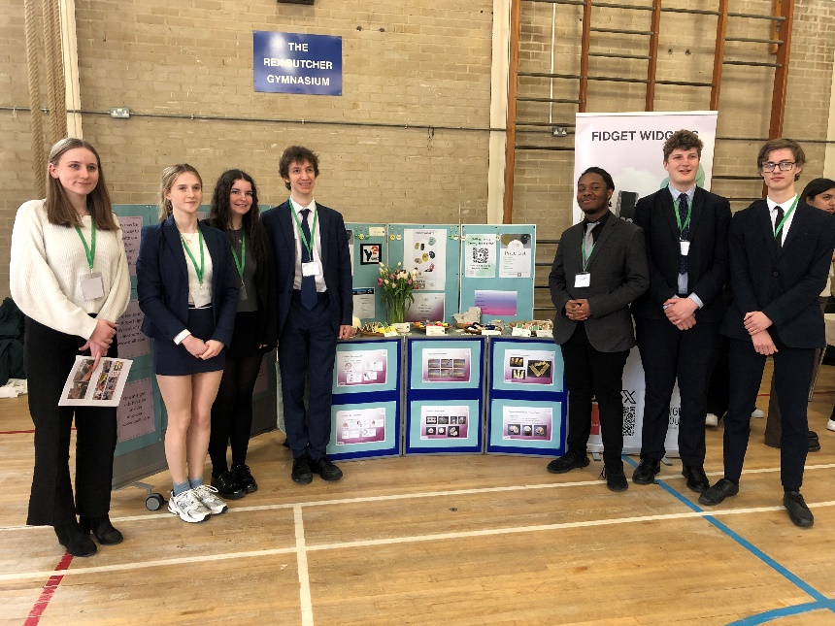
Young Enterprise Showcase - Awarded Runners-Up!

On Wednesday 24th April, our Y12 Young Enterprise team competed in the Chiltern Area Showcase Final, held at Chalfont Community College. Young Enterprise is a competition where young people work in teams to set up and run their own student company under the guidance of a Business Volunteer. This year our team – Light Touch – set up a company selling a range of “fidget widgets”. These are fidget toys which alleviate stress and anxiety – targeted at ADHD students in classrooms, and elderly people with dementia.
At the showcase the students competed against local schools including Chesham Grammar, Dr Challoners Grammar and High School, Chalfont Community College, Beaconsfield High and more. I am delighted to say they finished in second place overall, and they also picked up a trophy for Social Impact. In addition, their sales pitch was awarded third place in the Regional competition.
We are very proud of the team – Izzy, Ellen, Jake, Jacquan, Matthew, Rob and student advisor Tabitha!

