Peppa Pig Animator Inspires Students with Creative Insights
Award-winning animator James Butler visits our school to share his journey, creativity, and career advice.

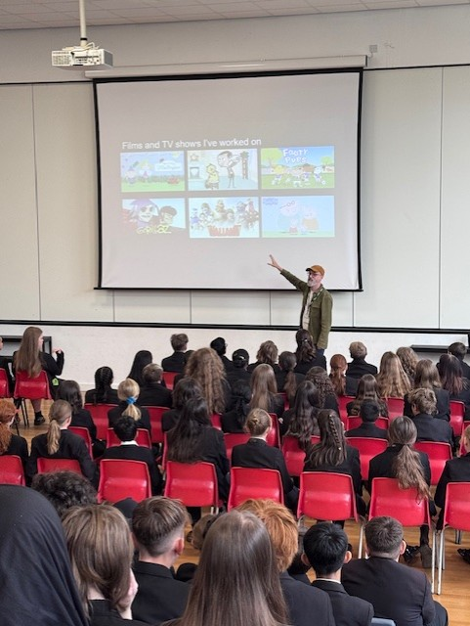
On Monday 13th October, we were very fortunate to welcome James Butler, an animator with over 20 years’ experience in the Animation and Creative industries.
Since 2006, James has worked on BAFTA and Emmy Award-winning shows including Peppa Pig and Ben & Holly’s Little Kingdom. He has also contributed to feature films, TV series, and commercials throughout his career.
During his visit, James shared fascinating facts about the creative industry — an industry that employs over 2.2 million people and contributes £108 billion a year to the UK economy.
He spoke about his personal journey into animation, explaining how he once had to drop Art at Sixth Form because it clashed with Maths, yet went on to study Electronic Imaging and Media Communications at university — proof that creative ambition can take many paths!
Students were amazed to learn that it takes an entire day to produce just four seconds of Peppa Pig, and around three years to make a full series. James walked us through each step of the animation process — from scriptwriting and storyboarding to voice recording, animation, editing, and music production.
Within the animation team, James explained, there are over 40 different roles, including designers, producers, editors, writers, art directors and even accountants — many of whom are neurodivergent. This diversity, he said, helps bring unique ideas and creativity to the screen.
James’s visit was truly inspiring, giving students a behind-the-scenes look at the animation world and the many creative careers within it and they came away feeling motivated to explore their own creative paths.

