Future Focused: Year 11 Step into University Life
On Wednesday 8th October, our Year 11 students had an exciting opportunity to step into university life as they visited three different institutions: The University of Hertfordshire, Bucks New University, and the University of Buckingham. The day was designed to give students a taste of higher education and inspire them to start thinking about their future pathways.
Students who visited the University of Hertfordshire enjoyed a Business taster session in one of the university’s impressive lecture theatres. The session introduced them to the world of business strategy, marketing, and entrepreneurship. Hertfordshire is well known for its strong business, engineering, and creative industries programmes, and students were particularly impressed by the university’s modern facilities and real-world focus.
At Bucks New University, students were split into smaller groups to take part in hands-on taster sessions covering Medical Studies, Cyber Security, and Sport. Bucks is recognised for its practical, career-focused courses and its supportive, community atmosphere. The sessions gave students the chance to explore how theory and practice come together in professional training—from learning about the human body to defending against cyber threats and understanding the science behind athletic performance.

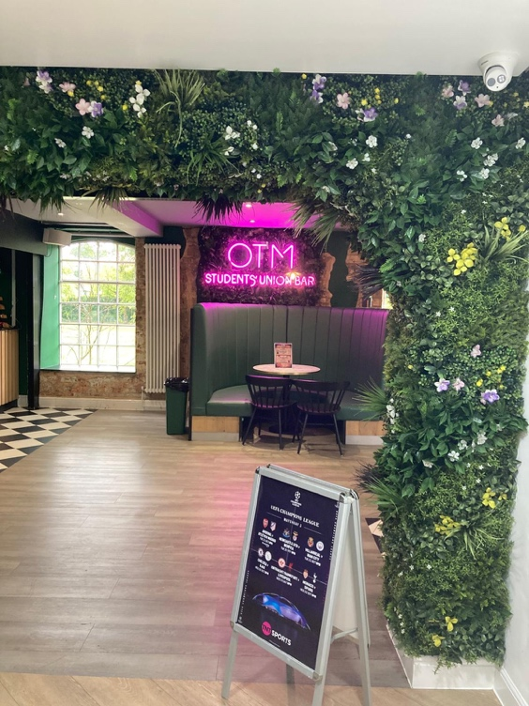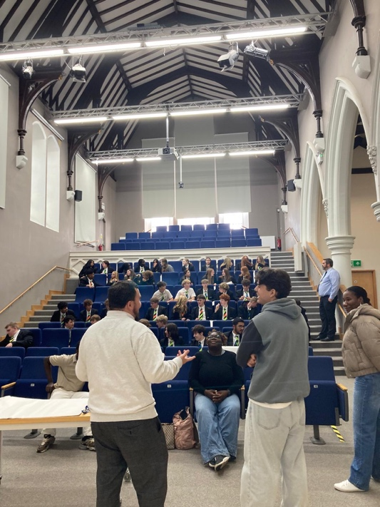
Those who attended the University of Buckingham experienced a range of sessions in Business and Entrepreneurship, Digital News and Media, and Psychology. Buckingham is renowned for its small class sizes, two-year degree structure, and strong emphasis on personal tutoring.

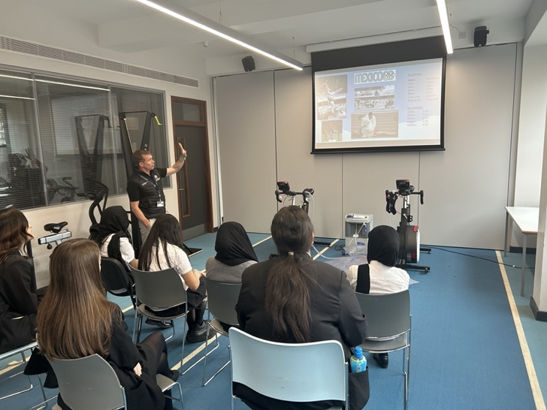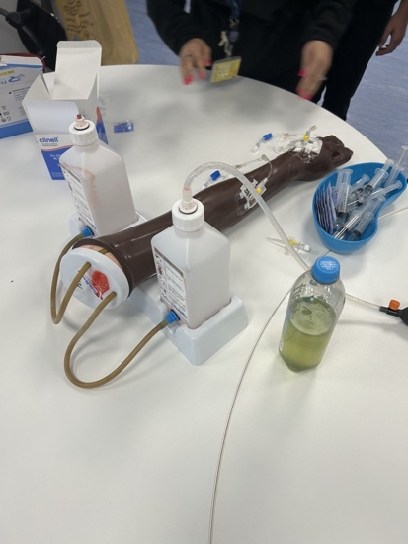
Across all three trips, Year 11 students came away inspired and more informed about what university life has to offer. These visits are a vital part of preparing for life after GCSEs—helping students to see the variety of options available, make connections between their current studies and future goals, and develop confidence about higher education.
“I enjoyed experiencing a different learning environment and looking at career options” Harley

“Great to learn about other people’s experiences and opportunities” Rueben

“I really enjoyed the taster sessions which gave me a feel what it would be like at Uni” Ebru

“It was so interesting to learn about the psychology of the brain” Kayley

“The sports facilities were amazing” Miley

“I loved how interactive the day was” Shadha

