Trip to Somerville College, Oxford University.
Last week some of our Year 8 students visited Somerville College, part of Oxford University. It was a fantastic opportunity to raise student aspirations and give them a taste of University life.
Somerville College was originally created for women only, when universities refused them entry, and remained an all-female college until 1992. Now Somerville female and male students represent the world and many go on to change that world too.
There are many famous alumni from Somerville including:
- Margaret Thatcher, Prime Minister of the UK
- Marjorie Bolton, British author and poet (taught by C.S Lewis and J.R.R Tolkein)
- Indira Gandhi, Prime Minister of India
- Dorothy Hodgkin, Nobel Prize winning scientist
- Esther Rantzen, TV personality

When the students arrived, they were given a talk on ‘Why University’ and ‘Why Oxford?’ and had a guided tour of the college. Afterwards, lunch was served in the vast dining hall (Somerville is one of the only colleges where you don’t have to wear your academic gown at formal dinners!)
After lunch, the students had a walking tour of Oxford to see St John’s. The last stop was the Museum where the students took part in a mini workshop.
It was an incredibly inspiring day which the students thoroughly enjoyed.


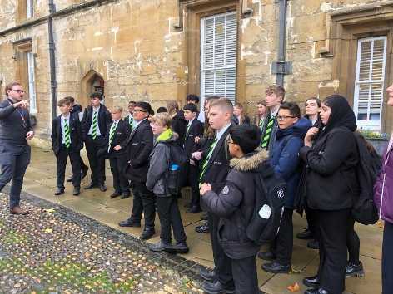
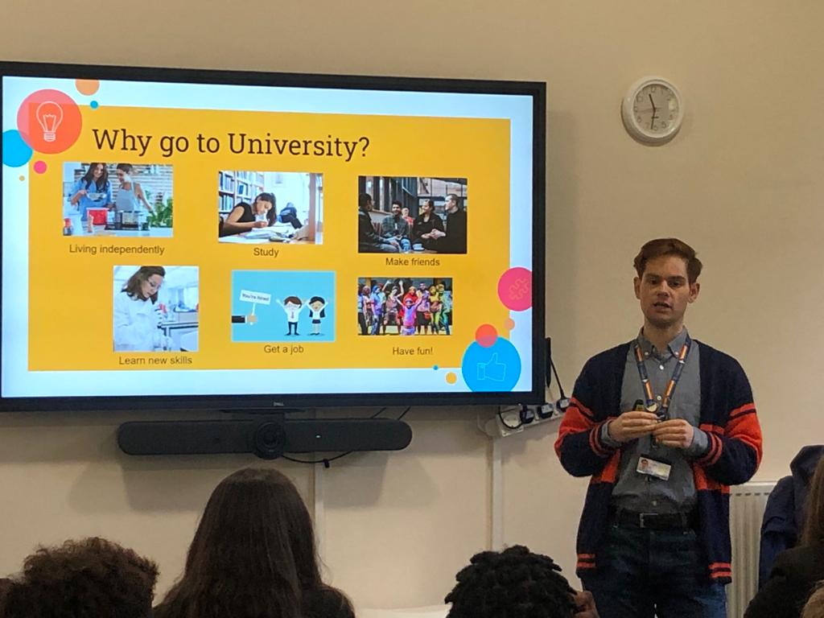

“I didn’t want to go to Oxford before but now I’ve completely changed my mind” Ida

“The trip was amazing. I loved seeing all of the insanely intricate buildings everywhere. There was a really positive environment and I thought the pollution bubbles were very interesting” Izzy

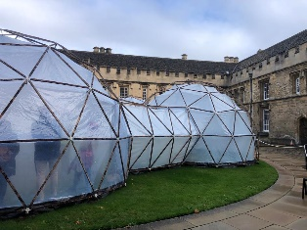
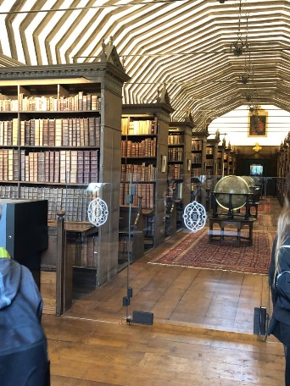
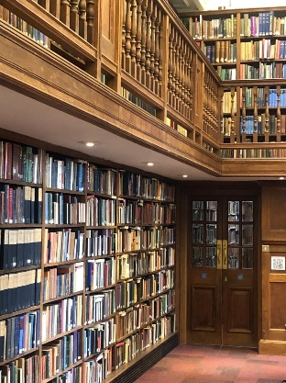
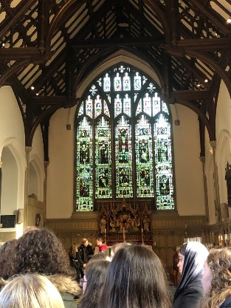
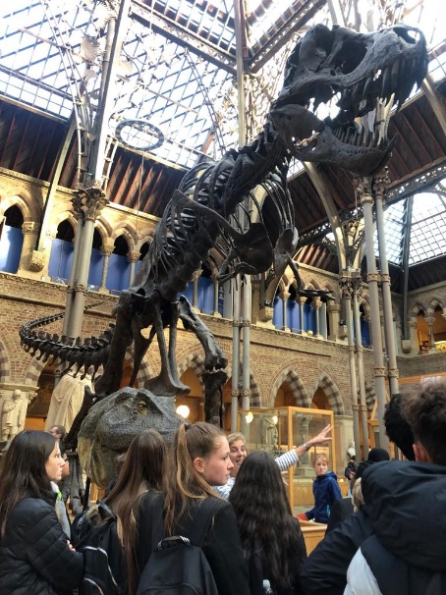
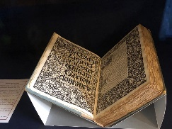

“Our trip to Oxford University was really fun. The architecture was beautiful and intricate. My favourite part was the guided tours and the pods representing pollution of 5 different cities” Sammi & James

“This trip has really inspired me to go to Oxford University” Rebekah

“We visited the old library and learned about its history dating back to King Charles 1. It was a wonderful day” Lacey & Aneesa

“I liked everything about the day. I hope to study there” Ayaan

